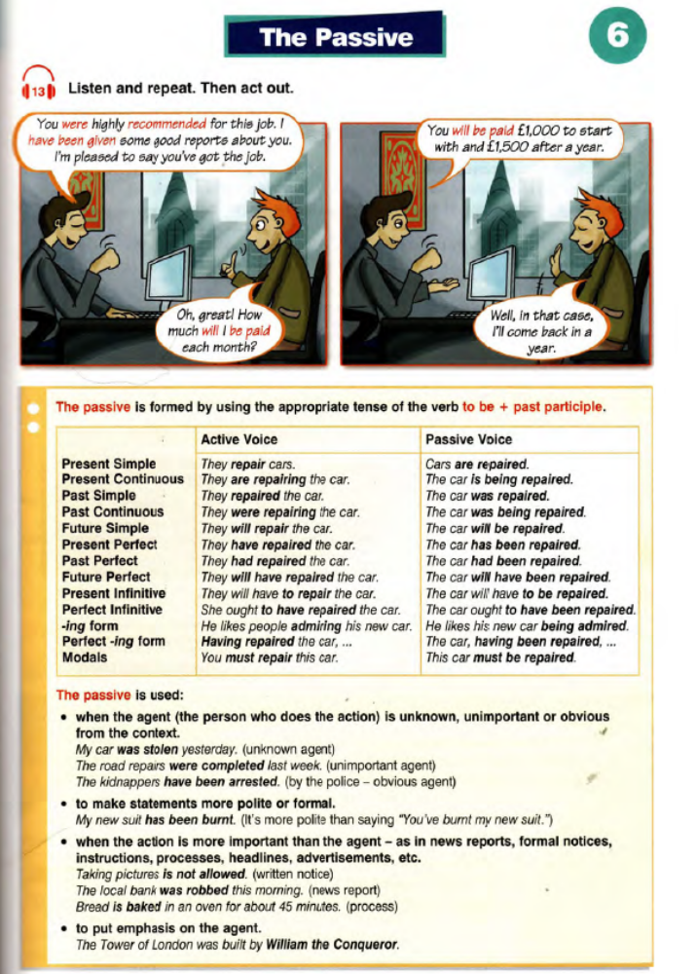
 | Active Voice | Passive Voice
Present Indefinite Tense | The Black Sea and the Sea of Azov wash Ukraine. – Чорне і Азовське море омивають Україну. | Ukraine is washed by the Black Sea and the Sea of Azov. – Україна омивається Чорним і Азовським морем.
Past Indefinite Tense | The Ukrainian Parliament proclaimed the Independence of Ukraine on August 24, 1991. – Український парламент проголосив незалежність України 24 серпня 1991 року. | The Independence of Ukraine was proclaimed by the Ukrainian Parliament on August 24, 1991. - Незалежність України була проголошена Українським парламентом 24 серпня 1991 року.

Переклад дієслів в Passive Voice українською мовою

Приклад | Переклад | Спосіб перекладу
- Ukraine is situated in the south-eastern Europe.  - The Independence of Ukraine was proclaimed by the Ukrainian Parliament on August 24, 1991.  - The new law was much spoken about. | - Україна знаходиться в південно-східній Європі.  2.1. Незалежність України була проголошена Українським парламентом 24 серпня 1991 року.  2.2 . Український парламент проголосив незалежність України 24 серпня 1991 року.  3. Про новий закон багато говорили. | 1.Дієсловом, що закінчується на –ся, сь.  2.1 Сполученням дієслова бути і короткої форми дієприкметника.  2.2. Дієсловом в активному стані  3. Речення, в яких зустрічається дієслово в Passive Voice зі сполучником перекладається на українську мову безособовим реченням, причому переклад починається зі сполучника

Exercise 1. Give Passive transformation of the following sentences as in the models. Translate the sentences.
Model 1 :
Population in Ukraine speak Ukrainian and Russian.
Ukrainian and Russian are spoken in Ukraine by its population.

- The Dnipro divides Ukraine into two parts: Right-Bank and Left Bank Ukraine.
- Ukraine is divided two parts: Right-Bank and Left Bank Ukraine by Dnipro
- The teacher showed students many colourful slides of London.
- Many colourful slides of London was showed students by the teacher.
- Railroads and highways criss-cross the territory of Ukraine.
- The territory of Ukraine criss-crossed by railroads and highways.
- Yesterday the Verkhovna Rada adopted a new law.
- The Verkhovna Rada adopted a new law yesterday.

Model 2:
The guide told us to visit the Independence Square.
We were told to visit the Independence Square.

- I invited her to the theatre.
- She was invited to the theatre by me.
- They took us for the excursion to Sophia Cathedral yesterday.
- We were taken for the excursion to Sopthia Catherdral yesterday.
- My friends gave me many beautiful presents for my birthday.
- I was given many beautiful presents for my birthday by my friends.
Exercise 2. Open the brackets using the proper form of Present, Past or Future Simple Passive.
Виктористовуйте подану таблицю неправильних дієслів щоб виконати вправу
burn – burnt –burnt give – gave – given sell – sold – sold
build – built – built send – sent –sent do – did – done
eat – ate – eaten
- My question was answered yesterday.
- Hockey is played in winter.
- Mushrooms are gathred in autumn.
- His new book will be next year.
- Flowers are sold in shops and in the streets.
- St. Petersburg was found in 1703.
- Bread is eaten every day.
- The letter was received yesterday.
- I was asked at the lesson yesterday.
- This bone will be given to my dog tomorrow.
- Many houses are built in our town every year.
- This work will be tomorrow.

Exercise 3. Ask your friend all possible questions to the following sentences.
Model:
Ukraine is situated in south-eastern Europe.
Is Ukraine situated in south-eastern Europe?
Where is Ukraine situated?
What country is situated in south-eastern Europe?
Is Ukraine situated in south-eastern Europe or in south-west Europe?
Ukraine is situated in south-eastern Europe, isn’t it?

- State power in Ukraine is based on the division of the power into legislative, executive and judicial.
- Judicial power in Ukraine is led by the Supreme Court .
- The problem of environmental pollution in our region was discussed yesterday at the meeting.
- The Independence of Ukraine was proclaimed on August 24, 1991.
- The Day of the Constitution of Ukraine is celebrated on June, 28.
Is the Day of the Constitution of Ukraine celebrated on June, 28?
What does Ukraine celebrate on June, 28?
Where celebrated the day of the constitution on June, 28?
Is the Day of the Constitution of Ukraine celebrated on June, 28 or on July, 28?
The Day of the Constitution of Ukraine is celebrated on June, 28, isn’t it?
Exercise 4. Say it in English.
1. Лекції цього поважного професора завжди чекають з нетерпінням.
2. На станції групу студентів зустрів гід та відвіз їх до гуртожитку.
3. Наступного року збудують новий корпус Університету.
4. Цю статтю написав один відомий французький журналіст.
5. Цю тему вивчили всі студенти нашої групи.
6. Їм будуть викладати німецьку мову.
7. Щороку навесні це поле вкривається зеленою травою та квітами.

